The link for download

[SQL Server Downloads | Microsoft](https://www.microsoft.com/en-in/sql-server/sql-server-downloads)

Step 1:

Step 2:

Step 3

Step 4

Step 5

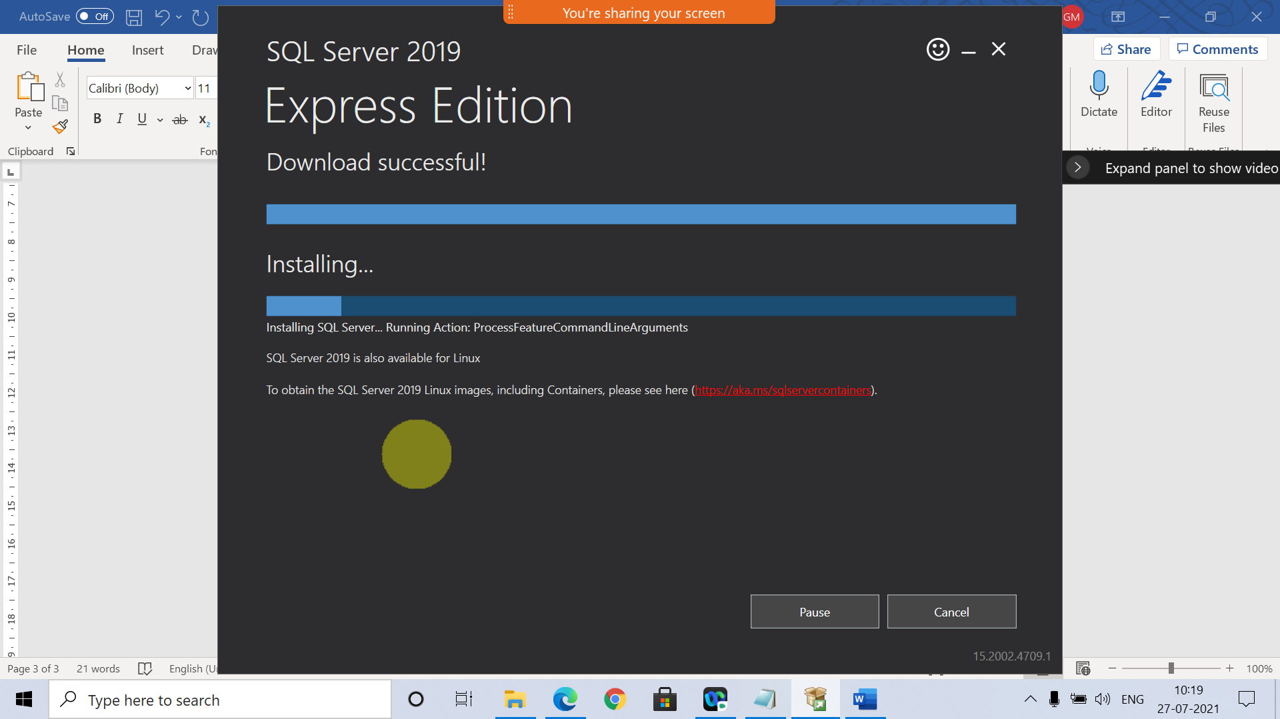

Step 6

Step 7

Step 8

[Download SQL Server Management Studio (SSMS) - SQL Server Management Studio (SSMS) | Microsoft Docs](https://docs.microsoft.com/en-us/sql/ssms/download-sql-server-management-studio-ssms?redirectedfrom=MSDN&view=sql-server-ver15)

